WEEK1 Assignment

**Task1 : TCP/OSI Models**

The **OSI (Open Systems Interconnection)** Model is a set of rules that explains how different computer systems communicate over a network.

OSI Model was developed by the **International Organization for Standardization (ISO)**.

The OSI Model consists of 7 layers and each layer has specific functions and responsibilities. This layered approach makes it easier for different devices and technologies to work together.

OSI Model provides a clear structure for data transmission and managing network issues. The OSI Model is widely used as a reference to understand how network systems function.

**Layers of the OSI Model**

There are 7 layers in the OSI Model and each layer has its specific role in handling data.

## ****Layer 1: Physical Layer****

The lowest layer of the OSI reference model is the **Physical Layer**.

It is responsible for the actual physical connection between the devices.

The physical layer contains information in the form of**bits.**Physical Layer is responsible for transmitting individual bits from one node to the next.

Common physical layer devices are [Hub](https://www.geeksforgeeks.org/what-is-network-hub-and-how-it-works/), [Repeater](https://www.geeksforgeeks.org/repeaters-in-computer-network/), [Modem](https://www.geeksforgeeks.org/difference-between-modem-and-router/), and [Cables](https://www.geeksforgeeks.org/types-of-ethernet-cable/).

Protocols: [USB](https://www.geeksforgeeks.org/universal-serial-bus-usb/), [SONET/SDH](https://www.geeksforgeeks.org/difference-between-sonet-and-sdh/)

## ****Layer 2: Data Link Layer (DLL)****

The data link layer is responsible for the node-to-node delivery of the message.

When a packet arrives in a network, it is the responsibility of the DLL to transmit it to the Host using its[MAC address](https://www.geeksforgeeks.org/mac-address-in-computer-network).

The Data Link Layer is divided into two sublayers:

* [Logical Link Control (LLC)](https://www.geeksforgeeks.org/logical-link-control-llc-protocol-data-unit)
* [Media Access Control (MAC)](https://www.geeksforgeeks.org/introduction-of-mac-address-in-computer-network)

Packet in the Data Link layer is referred to as Frame**.**

[Switches and Bridges](https://www.geeksforgeeks.org/difference-between-switch-and-bridge/) are common Data Link Layer devices.

Protocols: [Ethernet](https://www.geeksforgeeks.org/what-is-ethernet/), PPP

## ****Layer 3: Network Layer****

The network layer works for the transmission of data from one host to the other located in different networks. It also takes care of packet routing i.e. selection of the shortest path to transmit the packet, from the number of routes available. The sender and receiver's IP[address](https://www.geeksforgeeks.org/what-is-an-ip-address) are placed in the header by the network layer. Segment in the Network layer is referred to as Packet**.**Network layer is implemented by networking devices such as [routers and switches](https://www.geeksforgeeks.org/difference-between-router-and-switch/).

Protocols: IP, [ICMP](https://www.geeksforgeeks.org/internet-control-message-protocol-icmp/), [IGMP](https://www.geeksforgeeks.org/what-is-igmpinternet-group-management-protocol/), [OSPF](https://www.geeksforgeeks.org/open-shortest-path-first-ospf-protocol-states/)

## ****Layer 4: Transport Layer****

The transport layer provides services to the application layer and takes services from the network layer. The data in the transport layer is referred to as **Segments**. It is responsible for the end-to-end delivery of the complete message. The transport layer also provides the acknowledgment of the successful data transmission and re-transmits the data if an error is found.

Protocols used in Transport Layer are [TCP](https://www.geeksforgeeks.org/what-is-transmission-control-protocol-tcp/), [UDP](https://www.geeksforgeeks.org/user-datagram-protocol-udp/) [NetBIOS](https://www.geeksforgeeks.org/what-is-netbios-enumeration/), [PPTP](https://www.geeksforgeeks.org/pptp-full-form/).

## ****Layer 5: Session Layer****

Session Layer in the OSI Model is responsible for the establishment of connections, management of connections, terminations of sessions between two devices. It also provides authentication and security.

Protocols used in the Session Layer are NetBIOS, PPTP.

## ****Layer 6: Presentation Layer****

The presentation layer is also called the**Translation layer**. The data from the application layer is extracted here and manipulated as per the required format to transmit over the network.

Protocols used in the Presentation Layer are [TLS/SSL](https://www.geeksforgeeks.org/difference-between-secure-socket-layer-ssl-and-transport-layer-security-tls/) (Transport Layer Security / Secure Sockets Layer)

## ****Layer 7: Application Layer****

At the very top of the OSI Reference Model stack of layers, we find the Application layer which is implemented by the network applications. These applications produce the data to be transferred over the network. This layer also serves as a window for the application services to access the network and for displaying the received information to the user.

Protocols used in the Application layer are [SMTP](https://www.geeksforgeeks.org/simple-mail-transfer-protocol-smtp/), [FTP](https://www.geeksforgeeks.org/file-transfer-protocol-ftp-in-application-layer/), [DNS](https://www.geeksforgeeks.org/domain-name-system-dns-in-application-layer/), etc.

**TCP IP Model**

The TCP/IP model (Transmission Control Protocol/Internet Protocol) is a four-layer networking framework that enables reliable communication between devices over interconnected networks.

The TCP/IP model is a concise version of the OSI model. It contains four layers, unlike the seven layers in the OSI model.

## Layers of TCP/IP Model

* Application Layer
* Transport Layer(TCP/UDP)
* Network/Internet Layer(IP)
* Network Access Layer

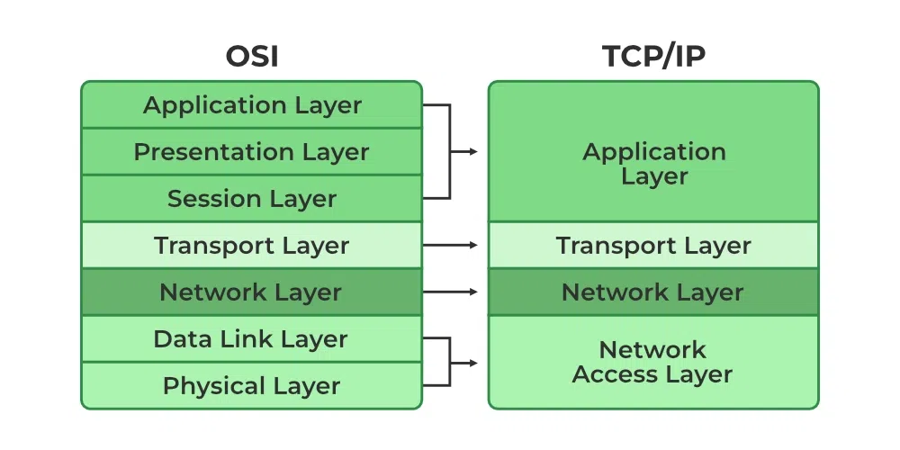

### 1. ****Application Layer****

The Application Layer is the closest to the end user and is where applications and user interfaces reside. It serves as the bridge between user programs and the lower layers responsible for data transmission.

* **Function:** Provides services and interfaces for end-user applications to access network resources.
* **Key responsibilities:**
  + Supports application protocols like HTTP, FTP, SMTP, DNS, etc.
  + Enables communication between software applications across networks.
  + Handles data formatting, encryption, and session management.

### 2. ****Transport Layer****

This layer ensures data is delivered reliably and in the correct order between devices. The two main protocols in this layer are TCP (Transmission Control Protocol) and UDP (User Datagram Protocol).

* **Function:** Ensures reliable or unreliable delivery of data between hosts.
* **Key responsibilities:**
  + TCP (Transmission Control Protocol): Provides reliable, connection-oriented delivery with error checking, retransmission, and flow control.
  + UDP (User Datagram Protocol): Provides faster, connectionless transmission without guarantees.
  + Manages flow control and segmentation/reassembly of data

### 3. ****Internet Layer****

It handles the routing of data packets across networks. It uses the Internet Protocol (IP) to assign unique IP addresses to devices and decide the most efficient path for data to reach its destination.

* **Function:** Determines the best path for data to travel across networks.
* **Key responsibilities:**
  + IP (Internet Protocol)**:** Provides addressing and routing.
  + Handles packet forwarding, fragmentation, and logical addressing (IP addresses).
  + Involves protocols like IP, [ICMP](https://www.geeksforgeeks.org/internet-control-message-protocol-icmp/)(for diagnostics), and [ARP](https://www.geeksforgeeks.org/arp-protocol/) (for address resolution).

### 4. ****Network Access Layer****

This layer is the lowest layer in the model and responsible for the physical connection between devices within the same network segment.

* **Function:** Manages the physical transmission of data over the network hardware.
* **Key responsibilities:**
  + Handles how data is physically sent over cables, Wi-Fi, etc.
  + Manages MAC addressing, framing, and error detection at the physical link.
  + Includes Ethernet, Wi-Fi, and other data link technologies.

**1. SSH (Secure Shell) — Port 22:-**  
SSH is used for secure remote access to the server. It is required to manage servers, deploy code, and perform various administrative tasks.

**2. HTTP — Port 80:-**

HTTP is the primary protocol used to transfer data over the Web. Port 80 is the default port for HTTP traffic.

**3. HTTPS — Port 443:-**  
HTTPS encrypts HTTP traffic for secure communications over the Internet. Port 443 is the default port for HTTPS.

**4. FTP (File Transfer Protocol) — Port 21:-**  
FTP is used to transfer files between a client and a server over a network. Port 21 is the default port for FTP control.

**5. SMTP (Simple Mail Transfer Protocol) — Port 25: -**  
SMTP is used to send email messages between servers. Port 25 is the default port for SMTP.

**6. DNS (Domain Name System) — Port 53:**  
DNS is responsible for translating domain names into IP addresses. Port 53 is used for DNS queries.

**7. MySQL — Port 3306:**  
MySQL is a popular relational database management system. Port 3306 is the default port for MySQL connections.

**8. PostgreSQL — Port 5432:**  
PostgreSQL is an advanced open-source relational database system. Port 5432 is the default port for PostgreSQL connections.

**9. Docker — Port 2375 (unencrypted) / Port 2376 (encrypted):-**  
Docker uses these ports for communication between the Docker client and the Docker daemon.

**10. Kubernetes API Server — Port 6443:**  
Kubernetes API Server exposes the Kubernetes API. port 6443